Miha’ Primer on Elasticities
Note: I am going to make some assumptions in my explanations here and make simplifications. Specifically, I assume we are dealing with perfectly competitive markets and homo economicus. I am also going to try to use non-economic jargon where possible.

Before we start looking at graphs, formulas and definitions, I want to briefly explain why elasticities are useful, or: why economists make us learn this stuff?

Who cares?
The problem when comparing two goods is that they are often very different things (ok, that was obvious, but bear with me!). Apples and iPhones are two very different products, for example, with vastly different economics of demand and supply. The price of a pound of apples is about $1. If I were to drop this price by $0.99 it would lead to price of $0.01 and sales would likely increase drastically. Now, assume that I also decrease the price of the new iPhone by $0.99 from $999 to $998.01 would sales also increase? Probably not. So comparing a price change in absolute terms is not very useful. If we look at this in relative terms we can explain why: price of a pound of apples decreased by 99% while the price of the iPhone decreased by 0.099% - lower by a factor of 1000!

It turns out that this is something that elasticities address: they allow us to compare the supply and demand responses (to price changes) of very different products. This is why they are useful.

Definition
Elasticity is just the %ΔQ/%ΔP. A verbose definition would be something like: elasticity is a measure sensitivity to change of another variable and is not limited to economics. What this means in practical terms is that an elasticity of greater than 1 suggests that a good is more sensitive to prices changes (elastic) and less than 1 that a good is less sensitive to price changes (inelastic). This holds for both supply and demand. Consider these examples:

Demand:
Apples: If I decrease the price of a pound of apples by 5% and the quantity sold increases by 10% that suggests an elasticity of -2 (10/5). We would say that demand is elastic.
iPhones: If I decrease the price of the iPhone by 5% and the quantity sold increases by 1% that suggests an elasticity of -0.2 (1/5). We would say that demand is inelastic.

Supply:
Apples: If I decrease the price of a pound of apples by 5% and the quantity produced decreased by 10% that suggests an elasticity of 2 (10/5). We would say that supply is elastic.
iPhones: If I decrease the price of the iPhone by 5% and the quantity produced decreased by 1% that suggests an elasticity of .2 (1/5). We would say that supply is inelastic.

Formulas

Elasticity is %ΔQ/%ΔP. For any given point on a line (“point elasticity”) this will become:
(slope)*(P/Q). For example, Q_{D}=-5P+100 with an equilibrium P=10 and Q=5 (I made these up) would have an elasticity of (-5)*(10/5)=-10.

In algebraic terms - where a line is defined as y=mx+b - this would be written as: (m)*(x/y). So, from the example above, we have a slope of -5 and an y-intercept of 100. BUT… things get a bit twisted when we graph this, because – for historical reasons – economists do not put Q on the y-axis, but rather P. Sigh.

Bad news:
This means that we need to rewrite the equation in terms of P in order to graph it the way economists expect. In the case above we can re-write Q_{D}=-5P+100 as P=(Q/-5)-20. Only then can we graph it to scale.

Good news:
You will not need to draw supply and demand lines to scale! So, you do not need to rewrite the equation. Simply draw a supply line and say this “D: Q_{D}=-5P+100” (or something to that effect). That is enough for us (unless explicitly told otherwise).

Graphs

Finally, I should note that elasticity it NOT the same on every point on the line. This is why we want “point elasticity” in which we identify where on the demand (or supply line we are). For example, here is a demand line:

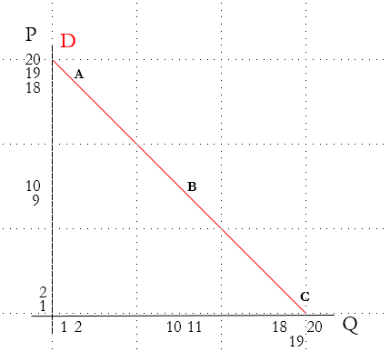

We have three points on this line: A, B and C.

The equation of the line is P=20-Q (slope is -1, y-intercept is 20).

The slope is -1 everywhere on the line. Elasticity it not! This is important to remember: elasticity is NOT the slope.

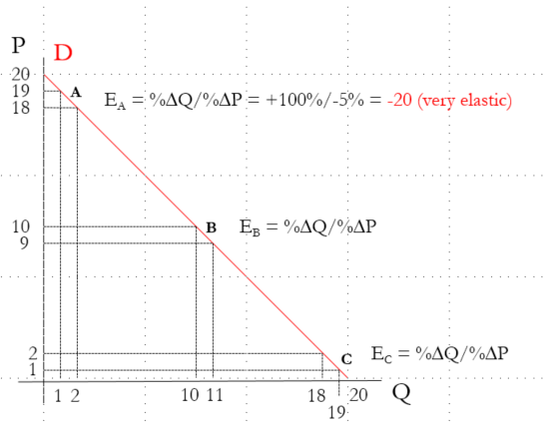

We can calculate the elasticity by looking at the % change in Q and % change in P at each point (going one dollar down in price).

Notice that the elasticity at Point A is -20. Quantity increase from 1 to 2 (100%) and price decrased from 19 to 18 (about 5%). However, elasticity is different for B and C, as you can see in the next image.

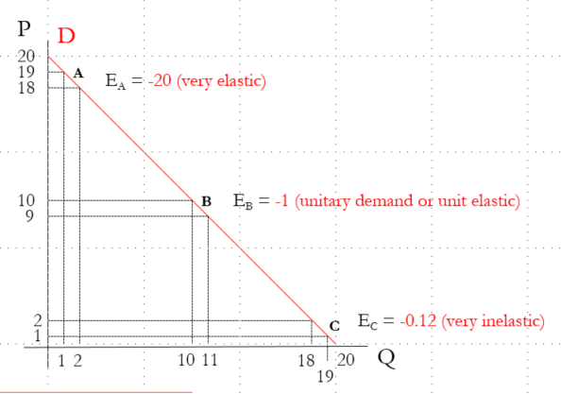

This is important to remember as it illustrates two points:
- Slope is NOT the same thing is elasticity.
- Elasticity is dependent on where you are on a demand or supply line.

What about “perfectly” elastic or inelastic goods?
Such examples are very, very rare (probably non-existant), but I wanted to include a few examples which might be treated as such. If someone every tells you that a good is not elastic at all or is completely elastic be very skeptical!

In extremis (these logical extremes are for rhetorical purposes only and probably don’t make much sense):

Demand:
A product with perfectly elastic demand is one with elasticity of ∞. Any increase in price will kill off all demand. For example, let us assume that people are completely indifferent to Coke and Pepsi and that they both cost $1. If Coke increased their price by $0.01 everyone would switch to Pepsi. Coke sales become 0. Likewise, if Coke decreased their price by $0.01 Pepsi sales would fall to 0.

A product with perfectly inelastic demand is one with an elasticity of 0. A change in price has no impact on demand. For example, if I could charge you for oxygen, I could change my price to whatever I wanted and you would have to pay me. Demand stays the constant no matter what I do.

Supply:
A product with perfectly elastic supply is one with elasticity of ∞. Any change in price will make production zero. This example will be crazy, but bear with me. Lets assume I am baking cookies and have decided that I do no want to make or loose any money from this business. Ever. It costs me $1 to bake a cookie. If the price goes above or below that 1$ my supply will drop to zero.

A product with perfectly inelastic supply is one with an elasticity of 0. Any change in price will have no impact on supply. For example, the Mona Lisa. There is one Mona Lisa and no matter what happens to the price there will still be one Mona Lisa.

There are plenty of good reasons, but I am going to simplify things to meet our needs. We are not meant to be experts on this topic, however, if you want to know how economists actually estimate elasticities I can fig up some articles.
The % change in quantity divided by % change in price.
http://www.investopedia.com/terms/e/elasticity.asp
Absolute value of the elasticity. Since elasticity of demand is negative, take the absolute value.
I round the numbers for simplicity.

